Self appraisal.

Create a program like the following:
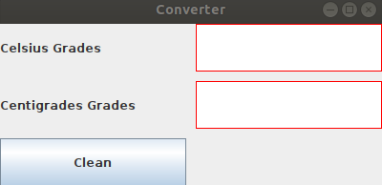

The operation is as follows:
- When you enter a temperature in degrees Celsius and press enter, it should appear converted into degrees Kelvin.
- When you enter a temperature in degrees Kelvin and press enter, it should appear converted into degrees Celsius.
- The clean button empties the contents of the two JTextFields.
Remember that 0 degrees Celsius (the degrees we usually use) are 273.15 Kelvin degrees. In other words, the absolute zero in Kelvin is 273.15. To obtain 1 degree Celsius in Kelvin you only have to add one to 273.15; that is, 1 degree Celsius is 274.15 Kelvin degrees.
It is very important that you try to do it. Once finished, compare it with the solved exercise.

